Dog Scout Texas Mini-Camp General Information & Orientation
(Almost everything you need to know for camp)

Are you really ready for the camp experience? It’s been a long time since we were kids at camp, and some of us never got to go to camp at all.

Rules: Campers have told us they were surprised by the volume of rules and safety precautions sent out and provided in the pre-camp materials, but then realized that most of the stuff was “no-brainer” material. All of the rules are really common-sense that the average adult human would not think we’d need to mention. As you read through the rules and policies, you may think to yourself, “Who would do that?” However, for every “no brainer” rule or precautionary statement we include, there has been a person who actually did what the rule covers, creating a potential hazard to self, others, and/or the property, and causing us to feel the need to enumerate every little “common-sense” rule. We don’t mean to insult anyone. We don’t mean to sound restrictive. All the rules are in place for your safety, enjoyment of camp, and protection.

Expectations: It’s all about expectations. Everyone has a different idea of what their camp experience will be like. If the actual camp experience does not exactly fit the mental image of the dream vacation you had in mind, then you will be dissatisfied. We don’t like to have dissatisfied campers, especially when it’s a simple thing like their own unrealistic expectations that make them dissatisfied (something that we have no control over.) So, we try to provide as much information ahead of time, and paint a picture for you that is accurate so you know what to expect.

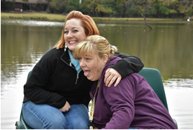
The camp community: By signing on for camp, you
are joining a little community for a few days. You will be
learning, playing, eating, and sleeping next to other adults
and their dogs. As a member of this new community, it is
your responsibility to follow rules and be a “team player”
just as you hope the other campers will so you can also
enjoy camp. All the rules we have in place have been
put there for the safety and preservation of yourself, those
around you and the camp itself. Because we are adults,
and not kids, we are used to having things just the way
we like them in life (we’re spoiled). For some, it is harder
than for others to co-exist in this camp community for a
few days. We just all try to get along. If you’re a “me-first”
kind of person, or feel your camp fee entitles you to be
rude, I can tell you right now that you are probably not going to enjoy this camp experience, which depends on your ability to share and work well with others who have paid the same fee.
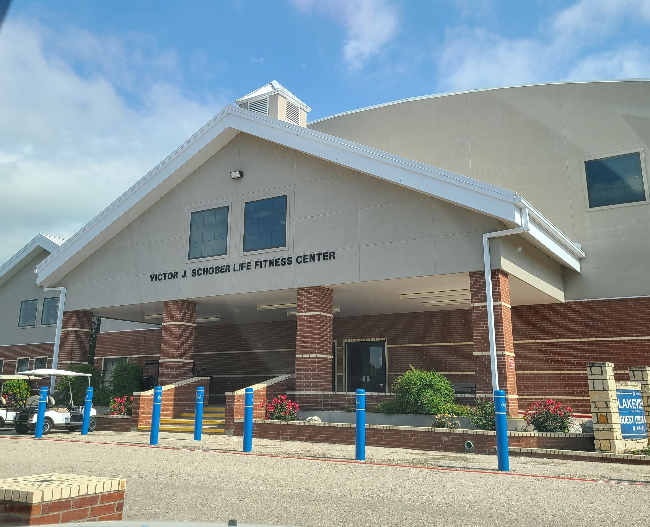

Arrival: Please plan to arrive as early as possible after 8:00 am on the first day of camp. Arriving early allows you and your dog time to settle in, get unpacked, stretch your legs, and get familiar with the camp layout before you sit for a while during the first sessions. When you turn into the camp property, go to the Fitness Center. Check-in upstairs in the Dogwood meeting room. There are outside stairs at the far end of the building and there is an elevator inside. We will kick things off with lunch at 1:00pm in the Dining Hall Thursday then return to Dogwood room for the first session. Please arrive at lunch early and ready to go!

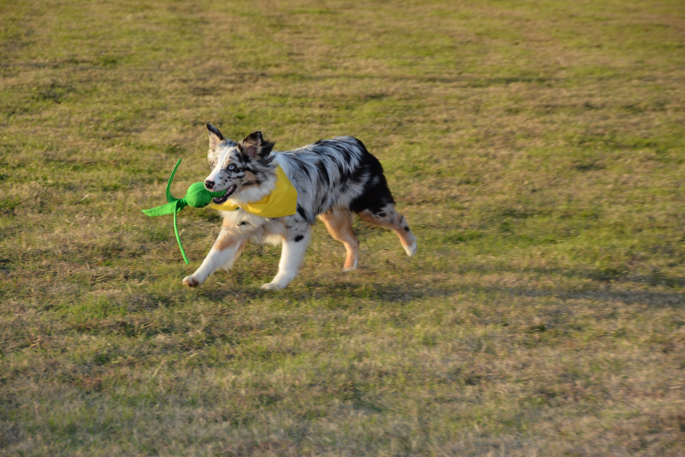
Off-leash area: Often after a long drive, your dog will likely want
to stretch his legs. The fenced play area will be by the blue fenced
pool. There is a tall zipline tower in the off-leash area so it’s hard
to miss. You MUST stay in this area with your dog or assign a
responsible adult that agrees to watch your dog. Please limit your
time in the off-leash area if others are waiting to use it and their
dog needs alone time in the area. You are also welcome to walk
your dog around the property but be sure he is on leash and that
you are prepared to pick up after him. Any bags of poop are to be
disposed of in the designated poop buckets only (5-gallon buckets
with lids). Please do not put any bags of poo in common area trash
cans.

Checking-in: As soon as you arrive, check in at the Fitness Center (Dogwood Room). You will get your cabin assignment so you can get settled in. Check-in is also when you will sign a release form and turn in your dog’s health form. If you are coming to camp for the first time, you will receive a 3-ring binder at check-in. You can use this to hold your badge check-off sheets, badge forms and informational handouts from the training sessions. Repeat campers should have a binder from a previous year and should bring it with them.
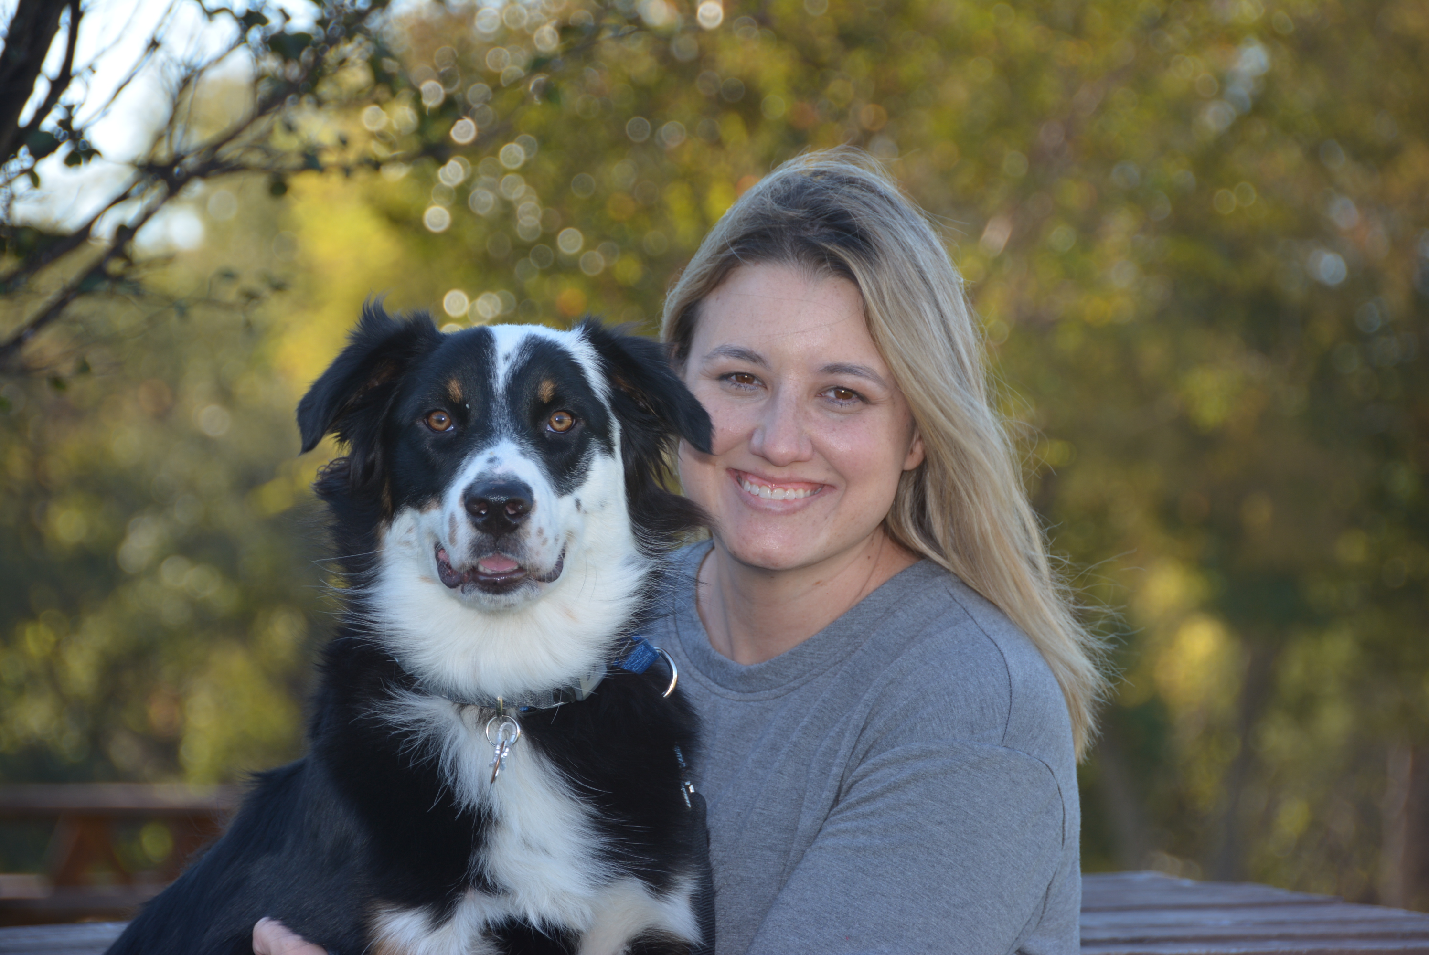

Photos: After the check-in time on Thursday, there will be a photographer available to start taking camper photos outside the Fitness Center. Once you have checked in, try to go ahead and get your photo taken with your dog so we don’t have to chase you down during camp. The camper photos will be included with all the camp photos and available after camp.

Lunch/ New Camper Orientation: Lunch will be provided in the Dining Hall on Thursday. New campers will lunch at the table with Mart & Cindy in the dining hall and have a New Camper Orientation during lunch to help fill you in on things to bring you up to speed regarding camp, answer any questions, etc.

First session: We’ll have introductions so you can meet the staff and fellow campers, point out where certain things and activities will be located and share other helpful info you won’t want to miss.

Classes and mini-seminars: We do offer some classes concurrently with other classes on the schedule. This means you will have to choose which one you will attend. Often these are classes that are for either a first-time camper or repeat camper and the number of times you have been to camp may play a part in which activity you should choose. There will be information on all the classes offered that will be emailed to all the campers to help you make your choices.


Dog Scout Class: If you are a first-year camper and your dog is not yet a Dog Scout, you will not want to miss the Dog Scout Class. Don’t make the mistake of skipping out during that session— everything you need to know to pass the Dog Scout certification takes place in that time slot each day. If you want to earn any of the merit badges, your dog must attend and pass the Dog Scout class. You must also be a DSA member in good standing for your dog to become a Scout. If for some reason your
dog doesn’t pass this test, you can hold on to any other badge forms
he might have earned and complete your Dog Scout test by video
(or in-person with a certified Scoutmaster if you have one in your area).

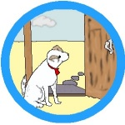
Merit Badges: Please consult your camp schedule as to the days and times each
activity is to be first introduced. It is imperative that you attend the "how to"
orientation and safety session (O&S) on each activity before engaging in that
activity with your dog. Each introduction session covers the mechanics of the
activity as well as rules and safety concerns regarding that particular activity.
After the introduction O&S for each activity, campers will then practice the activity
with instructor’s help and supervision. Activities are geared so that all or
most dogs can participate. If you miss a session, thinking your dog will not be able to or want to do that activity, and then change your mind, you'll be bummin’. For example, the Art of Shaping covers the basics used to teach everything at camp and all the badge activities. It’s way more than just painting! So, if you think you could skip that one, reconsider. It is especially important for you to follow the guidelines on the check-off sheets and training outlined in the associated pages for each badge. The activities taught in camp are progressive, and you must lay a proper foundation for subsequent training. Once your dog is checked off at one level and is ready to go on to the next, he does not have to be checked off again at the previous level. If he seems to "forget” what he did at the previous practice session, back up and repeat the last few things you were able to check off (review previous successful sequences) before moving on. Just because your dog has a checkmark by something does not mean he will never again need to review it. It is always a good idea to review the last thing your dog did successfully before moving on to a new level.


To earn the badge, we expect your dog to be able to repeat the desired performance, not just get it right once on a lucky fluke. Most of the work you do to earn the badge will be on your own, under the supervision of one or more instructors. The instructors will not re-teach everything during the class each day. That's why you must attend the instructional O&S portion and the first day of the activity. The purpose of the instructors is to help you with trouble areas, clarify things, maintain safety and traffic flow, or act as a spotter. To get your badge, your instructor must have witnessed you performing the required activities (items in bold on the check-off sheet).

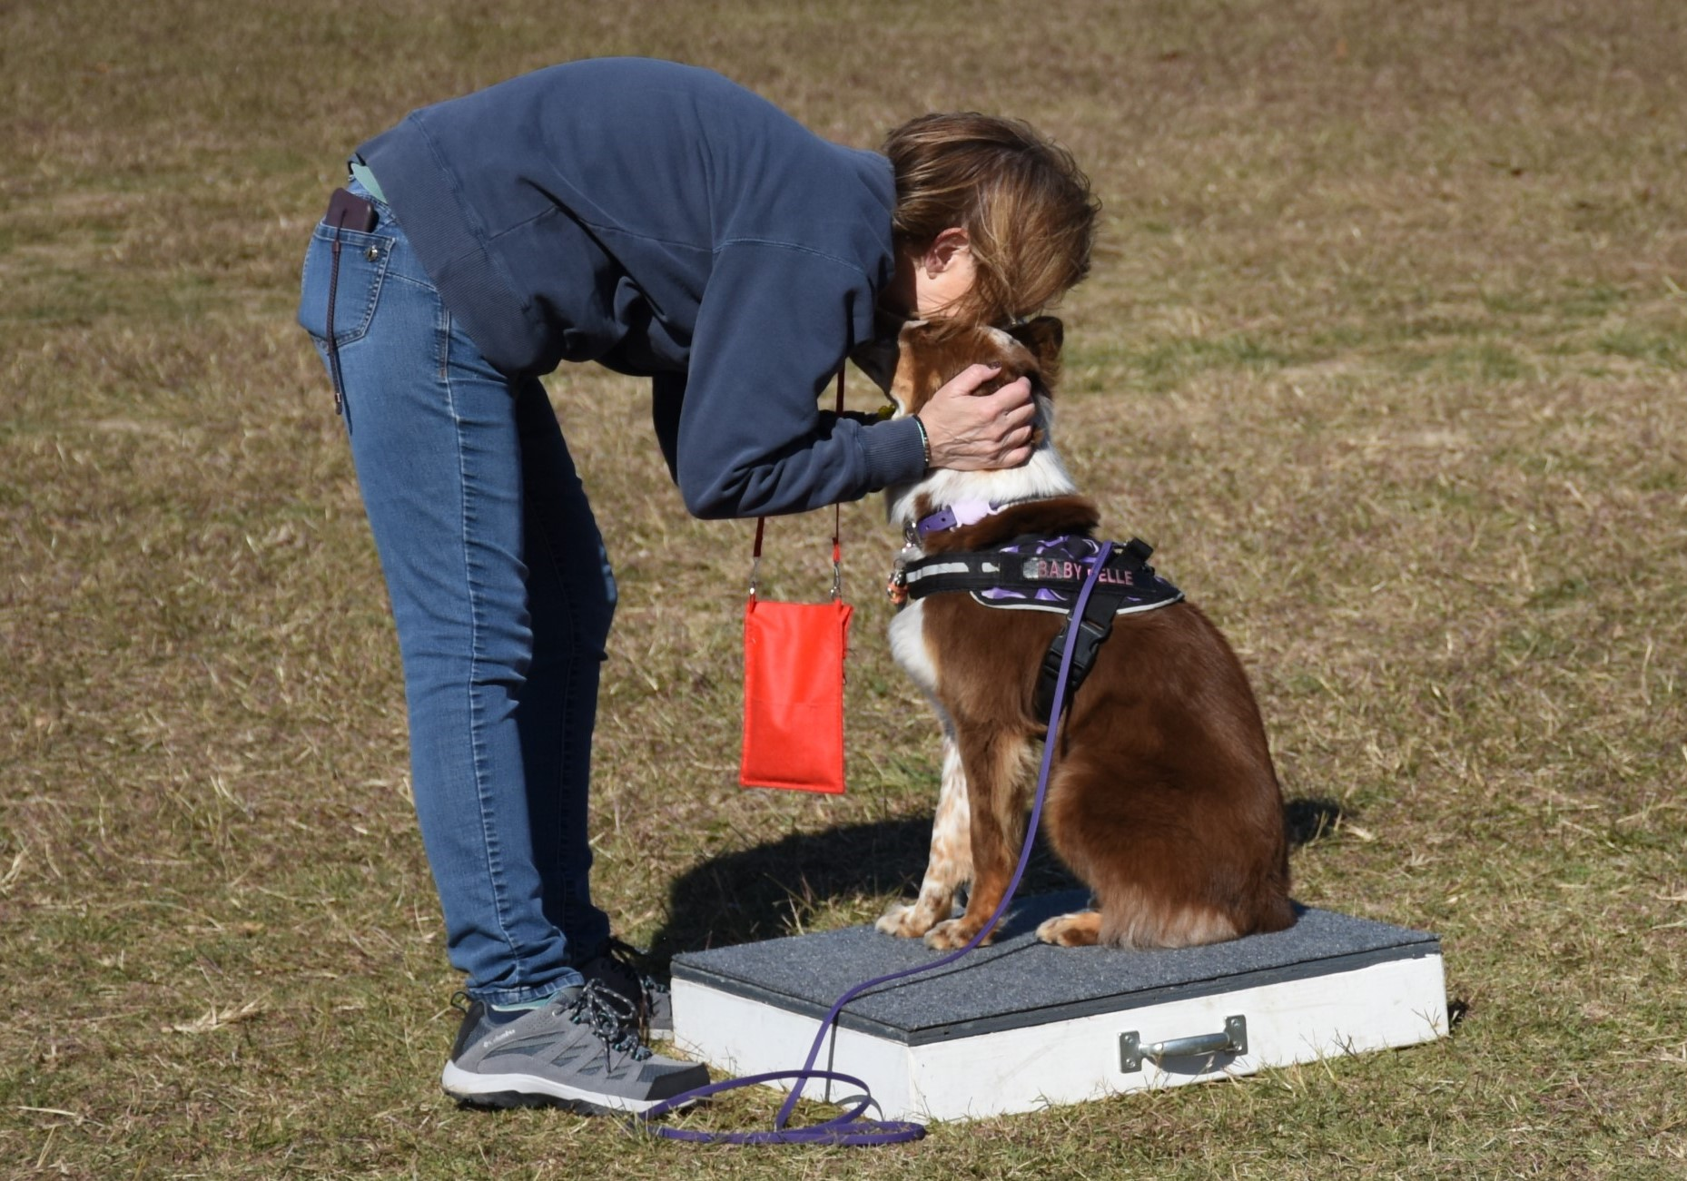
Practice time: You are also encouraged to practice the various
activities (once you have attended the introduction session) on
your own during your free time and start working on the behaviors
you can before camp. You will need to do this with the "buddy
system," as it will be easier and safer if you have a companion to
assess your performance or spot you if you need help. Equipment
will be in the field for your use, as long as you practice safely and
humanely. Instructors will offer help if they are in the area, but they
are only required to be there during the time which is scheduled for
that activity. For instance, if you decide to skip the art of shaping
practice time with your dog and go to the agility field, the instructor
won’t be waiting on the agility field for you. The instructors are
campers, too, or they might have other camp duties and they also need some down time to rest or work with their own dog. Because of safety concerns, we require that you get prior approval from one of the agility instructors if you wish to practice on the agility equipment outside of the scheduled class time. And if you go to the water or the agility field, we ask that you have another human with you for safety sake.

Note: While we try to be uniform, not every instructor, co-instructor, or assistant instructor teaches the same class the same way. If you are told one thing by one staff member, and another by a different staff member, you may not know what to think. They are not trying to confuse you. If it’s regarding training, be aware that there are about as many ways to train something as there are instructors. You can let the instructor know what you have been doing so far and then get advice if that’s not working for you. If it is a difference in requirements for a badge checkout, please contact Mart or Cindy to get the final word on the matter. Every now and then, we may have to clarify something for an instructor who is making certain requirements for checkouts that are simply not needed. Or two instructors may be checking off the same merit badge, but one might be more lenient and the other more strict. I assure you, they are each trying to do their best to uphold the standards of Dog Scouts of America. It may also be a badge that was recently updated and the instructor might be using what was previously required out of habit.

Trails: There are only three actual backpacking sessions: a one-, two-and three mile hike on consecutive days. The requirements for your merit badge are that you complete the 3-mile check-out hike and log in a minimum of at least 6 miles of backpacking over the time of camp. It takes about 20 minutes to walk one mile. You can make up a hike on your own time if you miss the group hike. Remember to have your log signed by your hiking buddy to verify your mileage. Save your backpacking log page, as your miles qualify for pack dog titles. We would appreciate it if you want to walk the property outside the main area of camp during non-scheduled backpacking times, if you would take a human buddy along or at the very least, let a friend or cabinmate know where you are going. You may take hikes any time you feel like it during the day but we appreciate you not going alone.

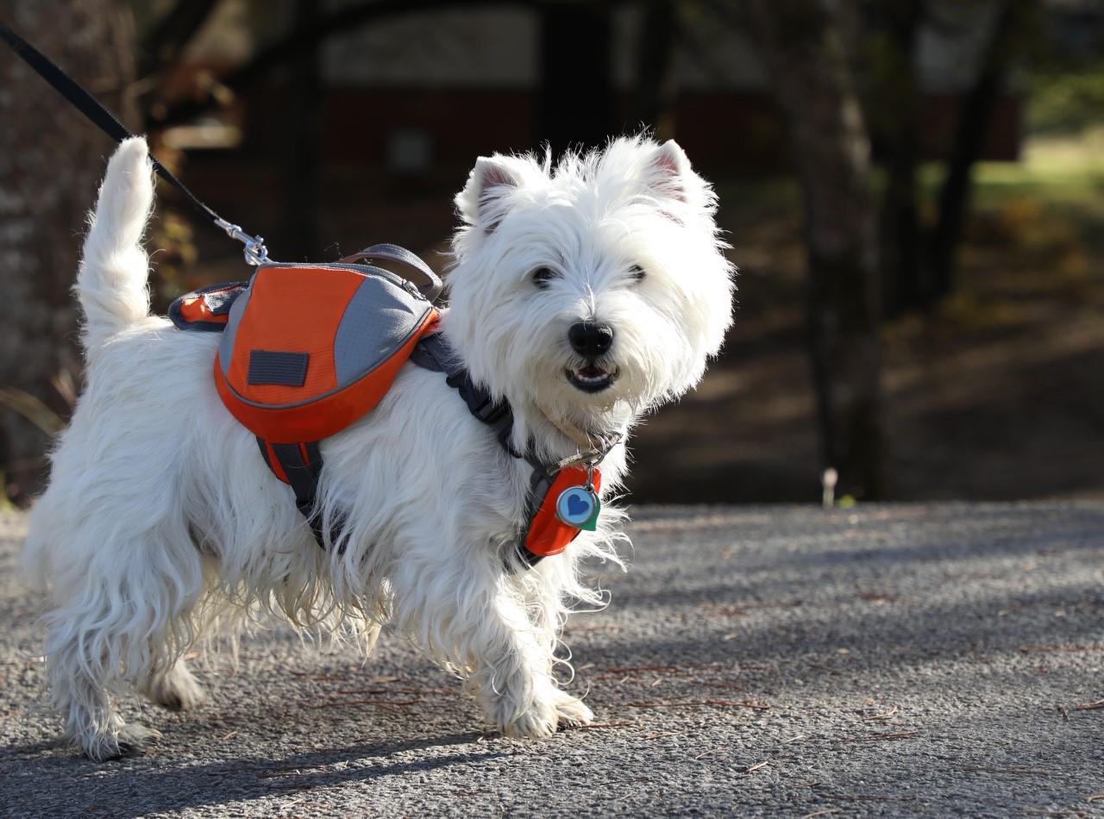

Backpacks: If you do not have a backpack for your dog,
we recommend you pick one up locally or order one from
the online store and have it shipped ahead of time so your
dog can get used to wearing it prior to camp. There is a
limited supply in the online store of our adjustable, convertible, and affordable Dog Scout Packs that come in several sizes from tiny to extra-large. These fit over a Premier Sure-Fit harness which comes with the pack. It is recommended that you order your pack in advance, so you have time to acclimate your dog to wearing a pack based on the training advice found with the Backpacking badge forms (on the DSA website).

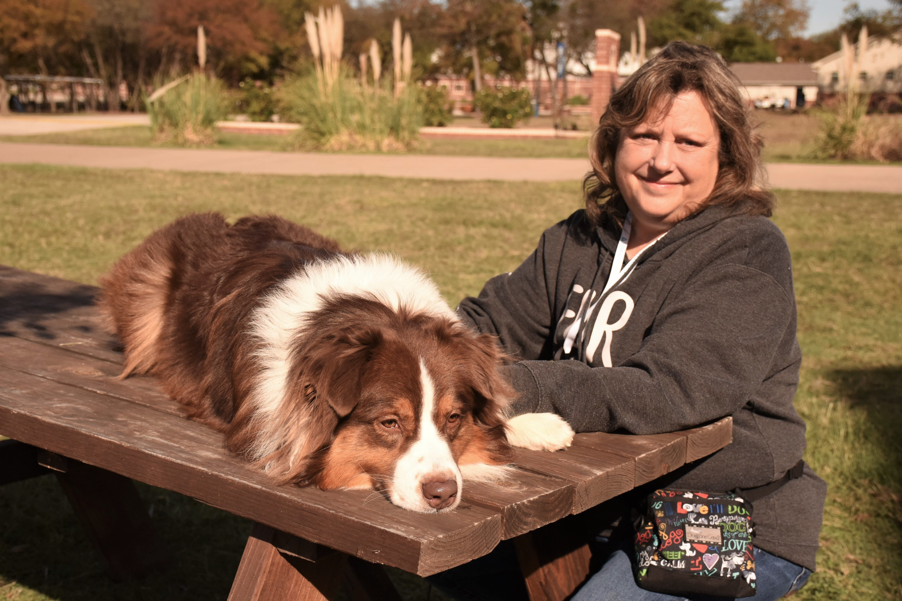
Pace Yourself: There are many areas of activity being officially offered at camp which are eligible for merit badges upon completion. You are not required, nor expected, to complete them all. It is possible that you have a dog which could earn a lot of the merit badges offered at a camp. However, I suggest that you don't go overboard trying to master all activities introduced here at camp. There will be other camps and other chances to complete your merit badge requirements in the future, even after you get home (by video or for a certified Evaluator). To get all your badges on the first try, you will
be busy morning, noon and night, sacrificing all of your
free time, and your dog will likely be getting tired and
stressed. Especially if he is used to sleeping for 8+ hours
a day while you are at work! Fun is why we are here!
You don't have to make your camp time a marathon.
Take it easy. Have fun. Enjoy your dog. For some people,
it’s “all about the badges.” For others, they could care
less about the badges and don’t even try to earn them.
Most dogs sleep all day! They are not used to this much
activity and need their own rest time so they don’t get
grumpy. We will repeat this warning over and over at
camp. Even though we recommend that each camper try
only a few merit badge activities per camp, there will still be people trying to do it all, and blaming us because they’re tired at the end of the weekend and their dog got snappy. Please keep in mind that YOU are responsible for making sure you and your dog do not become too stressed by overactivity during camp. In addition to the advertised activities, your week will include options for fun and games, interesting lectures, contests, and campfires. There will be more than enough to keep you busy, but if you get overwhelmed, you can always just take time out to relax. If you find your dog is the one needing a break, you are welcome to attend classes without him so you can still learn from watching others and hearing what the instructor has to say.

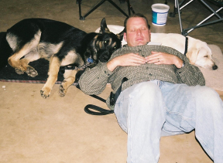
Quiet, Please! Because the camp schedule is full of fun things to do all day, many campers choose to get up early to get in a “make-up” hike or do some early morning tracking. If you are an early riser, please be mindful of our “no noise times.” After 10:00 pm and until 7:00 am, you must not have any “noisy” fun. Don’t let your dog bark or do any other noisy activities, like retrieving a toy from the water, during these times. If we have a campfire sing-along, or “group howl” it will be finished before 10:00 pm. Be aware of the noise level and be courteous of others who are trying to rest. You may want to bring some rubber bands for your dog’s tags if they jingle or purchase a tag silencer from the camp store and you might want some ear plugs (available in the camp store) if anyone (or any dog) snores.
If you arrive for camp before 8 am or after 10:00pm, please just bring in your sleeping bag and pillow and do your best to quietly find your room and bed. If you plan to arrive before or after hours, please let Cindy know (cell 817-821-5826) so she can give you your cabin assignment.
Both people and dogs are meant to enjoy their stay at Dog Scout Camp. Please be mindful of the rights
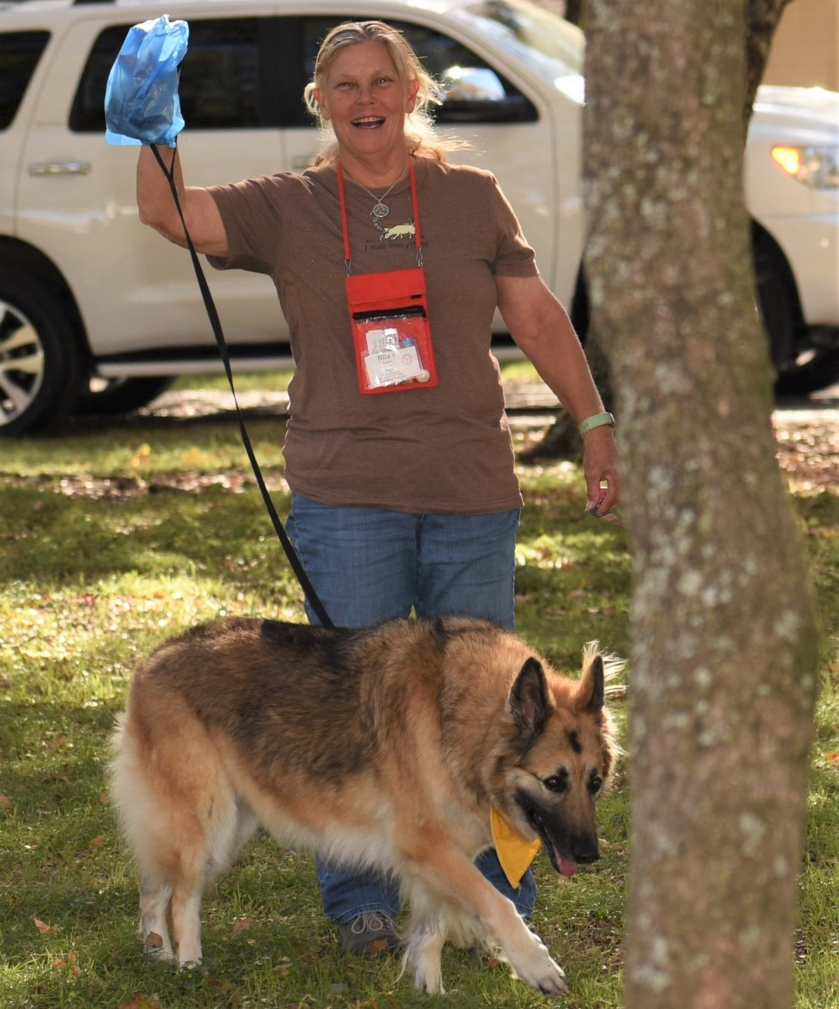
of others. It's nice to be out in nature and let your dog run and play, but please do not let your dog run off leash around camp and do not give your dog freedom at the expense of the other camper's enjoyment of their vacation experience. Dog Scouts must get along well in groups, but please do not let your dog force himself on someone else or their dog(s). Please do not let your dog out of your sight unless he is crated. It is a definite “no-no” to have your dog outside while you are in a building, loose in a building while you are in another area or tied out when not in your direct sight. Each dog must be supervised and with a person in charge of watching him/her while in the off leash play yard.

Clean-up after your dog: As always, we must clean up after our dogs.
Please bring plenty of clean-up bags. Clean-up bags are required in
your dog's backpack when you're on the trails. Clean-up bags must
be disposed of properly and only in the 5-gallon buckets designated
for that purpose. Please be sure to securely tie/close the bag!
Mart & Cindy have to dump the buckets into the dumpster after camp
and open bags that spill their contents make the job even less pleasant!
Yuck! All the buckets have an extra trash can liner in the bottom. If a
poop bucket gets full, please pull the bag out and tie it shut (securely)
and pull out the empty can liner and put it in the can.

Poop Police: We must set an example as responsible dog owners both at camp and after you return home. It is rare to find any poop on the grounds at camp. Dog Scout Camp has its own “Poop Police.” They are out to “bust” you! Of course, we believe in positive reinforcement training, so we don’t punish you if you’re caught without your baggie. However, if you’re busted carrying baggies (AND are wearing your name tag) the Poop Police officer will give you a ticket. On this ticket you write your name, and then you put the ticket in the drawing bucket in the dining hall. We make several drawings at the beginnings of each meal, and you could win some nice prizes, just for being a good dog owner (and wearing your name tag and showing up on time for
meals)! You must be present to win when your name is called. So you’ll want to get to the meals on time. If
you do happen to find a stray pile, you can get an extra ticket for the drawing if you pick it up and dispose of the stray pile properly. Piles left by wild animals do not count :-)

Good Camper Tickets: We also have camp “helper” awards. You get a drawing ticket for such things as the “stray poop picker” drawing. You should see everyone diving for that pile that someone overlooked, so that they can get into the prize drawing! There will also be tickets hidden around camp. If you find one, put your name on it and place it in the mealtime drawing bin.

The Mark G. Echterling Spirit Award: Mark Echterling was a camper, an instructor,
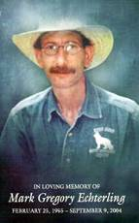
a staff member and a friend to all who knew him through Dog Scout Camps. He
began his relationship with Dog Scouts of America as a camper and became so helpful
and invaluable, that he quickly became a staff member for each of the summer camp
sessions. Mark was a quiet but strong influence at camp. He quietly sought out the
campers who seemed to be struggling and offered encouragement and assistance in
any way he could provide. We personally met Mark when we attended our first summer
camp in 2001 and he quickly became a favorite friend! Mark founded Echo Dogs White
Shepherd Rescue in 1999 and that is where we turned when we were looking to adopt a
new family member in 2006 and brought our Zeke into our family. Mark passed from this earth in 2004 after an 18-month battle with lung cancer. The Mark G. Echterling Spirit Award is presented to someone at each camp who exemplifies Mark’s spirit of contributing in an extra helpful way to camp. Nominations can be made for campers or staff members during the weekend of camp and the Award will be presented on Sunday evening during the Awards ceremony. Nomination forms will be on a table in the Dogwood Meeting Room with a container to place them in.

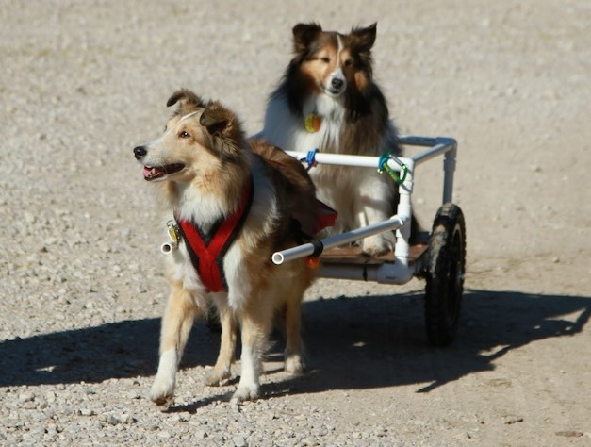
Questions? Some of the staff working at this camp have been chosen because of their involvement in many different dog activities. Others have been chosen because of strength in one particular area. Please see the "Meet Your Staff” section of the pre-camp material for a short biography on each instructor. If you have a question about a particular topic, there may be one staff member more qualified to answer it than another, depending on their background. If the person you ask does not feel prepared to answer your question correctly, he or she will find someone who can. Most of our campers have been to camp before and know the answers to most questions. They would be available to give advice, share stories, and spill their guts about some of the camp secrets, private jokes and training tips. To locate a repeat camper, simply look on their name tag and you’ll be able to see how many camps a person has attended and campers who have attended mini-camp three or more years will (hopefully) be wearing their Happy Camper pins!

Where the Heck Are We? If you want to let someone know where you are,
the camp is Lakeview Camp & Retreat Center, 5128 FM 66, Waxahachie, TX
75167. If someone needs to get in touch with you & can’t reach you on your
cell, they can call Cindy’s cell phone: 817-821-5826.

Cancellations: If you can’t come to camp at the last minute, or you leave camp for any reason, including an emergency, such as an illness, your camp fee is not refundable, as your spot cannot be filled at that late date. If your dog comes into heat just before or during camp, you do not have to withdraw from camp. You do have to work harder to keep away from the intact male dogs (it’s not fair to them), and you must have your dog wear a panty and something to mask the scent. If you are rooming with anyone who has an intact male dog, you will be moved to another room, where your female’s presence will not be so compelling to the male. If you suspect your female may come into heat during camp, it may be better to bring a different dog, if you have that option.

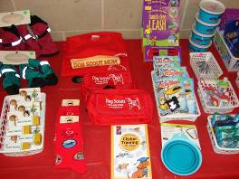
Shopping: The mini- camp store is open all day, and you will have a tab sheet at the store. You’ll need to pay your tab when you check out on the last day before you leave camp. The best time to hit the camp store is before camp starts, or the morning of the first day. Shop early and often! At check-out, we will ask that those leaving Sunday night that have a ways to travel be allowed to settle their tabs first so they can get on the road. After that, we will ask that you settle your tab alphabetically, according to your last name, to keep everyone from having
to stand in a long line (we’ll be alternating A-Z and Z-A every other year).
We are not set up to receive credit cards so we can only accept checks, cash for Zelle payments (sent to Cindy’s cell # 817-821-5826). There are ATM’s in town if you need cash to pay your tab. Check or Zelle is the preferred method of payment as we will not have cash on hand to make change.
Bathrooms: The bathrooms and showers are in the cabins where you will sleep. No one should have to stand in line and wait for a shower for more than a few minutes. There are also bathrooms in all the buildings on the property as well as at the picnic area in front of the dining hall. The RV park has a shower & bathroom building for it as well.

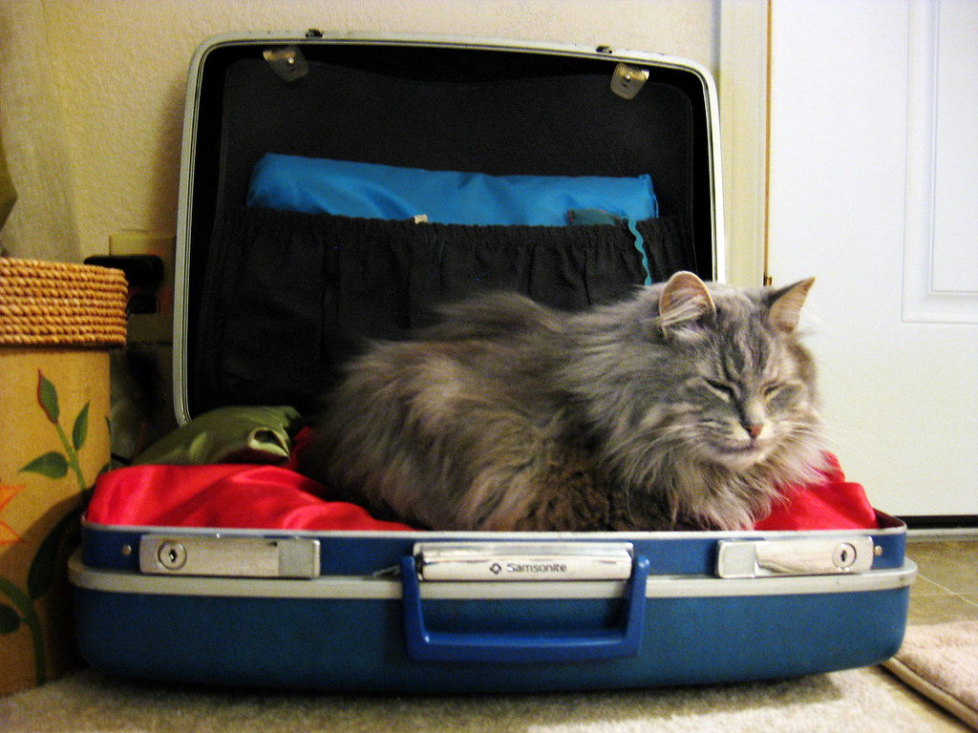
Visitors to camp: We regret that we cannot allow you to invite anyone to come to camp to “visit.” There is no provision for visitors. Anyone who sets foot on the campgrounds must be insured, must sign the release form, must have viewed the pre-camp material, and must know and obey the camp rules. Therefore, we cannot allow unregistered guests to come into camp. Dogs not registered for camp in advance and any animal other than a dog are not allowed on camp property. This is for the health and safety of the registered dogs and for the health and safety of the dogs and other pets the campers will be going home to.

Meals: The meals are prepared at camp and the menu is
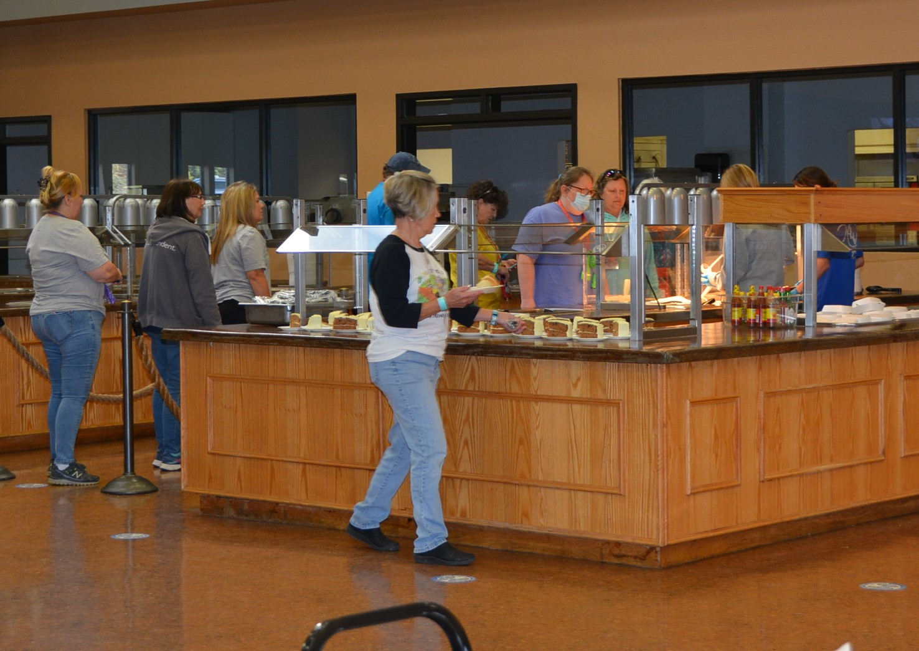
decided in advance. Lakeview sets the menu but the food
is very good and not typical “camp food”. If you have
specific dietary requirements (vegetarian, vegan, have
celiac disease), you will need to let us know ahead of time
and the kitchen staff will accommodate you. Otherwise,
it is not Burger King so please don’t make demands of the
kitchen staff. There will be hot breakfasts each morning
and a salad bar and fruit with lunch and dinner. We will
email the menus to campers ahead of time so you will
know what to expect. Most campers find that they stay
so busy at camp, that by the time mealtimes roll around,
they are so hungry they’ll eat anything! You are welcome
to bring snacks to camp but please be sure they are out
of reach of any of your canine cabinmates. There will be
refrigerators and microwaves in most of the cabins for
your use. Please do not go back through the food lines
until everyone has had a chance to get their first helping.
Please only take the amount of food YOU will eat (camp food is not for your canine). There is the possibility there may be other groups at the camp during the time we are there. If so, mealtimes may be scattered between the different groups. Please arrive on time for meals as there may be another group scheduled to eat after ours. Our mealtimes are set for 45 minutes but we’re usually wrapping up after about 30 minutes and moving on to starting the auction and we need to be cleaned up and ready for the next activity by the end of the scheduled mealtime. Your dog will not be able to go through the food line with you and we encourage you to leave your dog in the cabin during mealtimes and let them have some quiet time and rest.

Stray food: Lakeview does not allow for any food to be taken from the dining hall or any leftovers or table scraps to be given to your dogs. This attracts insects and little animals (not to mention not being good for your dog’s digestive system).

Responsibility: You are responsible for your own dog… to make sure he is not a nuisance, to make sure he is not barking, and to make sure he is safely contained or under your control at all times. You need to bring a crate to camp with you. There may be very few times when your dog will actually have to go in the crate, however, it will be there for him to rest in, undisturbed, when you need it, like when you take a shower and attend the few human-only activities. Remember you are responsible for keeping your dog on a leash, crated or otherwise under your control at all times. Please read the release form carefully. It states that you are responsible for your dog, no matter what happens.
Identification: In the unlikely event that a dog would run away from dog camp (You’ve got to be kidding! This is the most fun he’s had in his life!), we recommend that your dog wear an I.D. tag to camp with your cell phone number or another number where someone can be reached if no one is at your home.

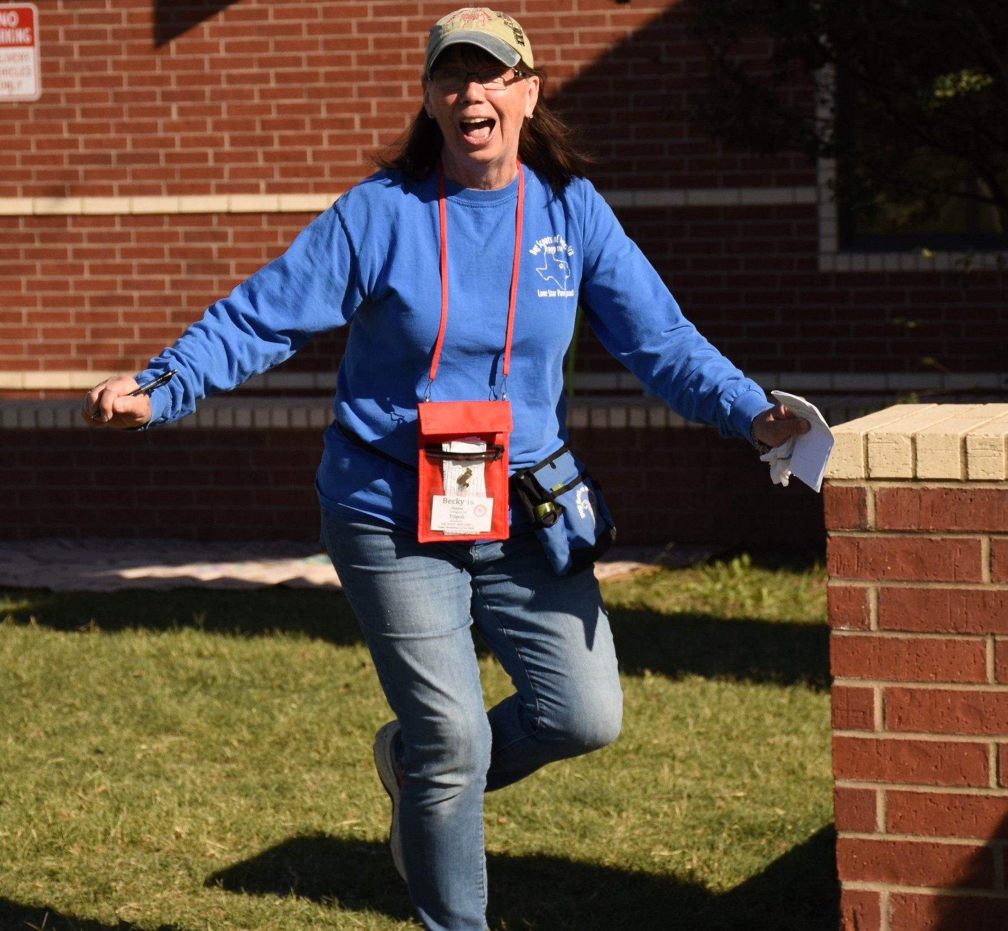

Wildlife: There could be a fair bit of wildlife at camp. Possibly deer, armadillos, coyotes, skunks, and snakes in the area. Don’t let your dog harass the wildlife. He might run down the trail after a deer, and not turn back for miles (as even an honor scout once did, a dog the owner would have bet big money wouldn’t run off and ignore a recall cue). As for most of the wild animals, they don’t hang around the populated areas. When we go on our hikes, your dog should be on a leash unless they have been pre-approved for hiking off leash. Remember, porcupines don’t run very fast— they don’t have to!

What To Bring / Auction: You will receive a list of suggested items
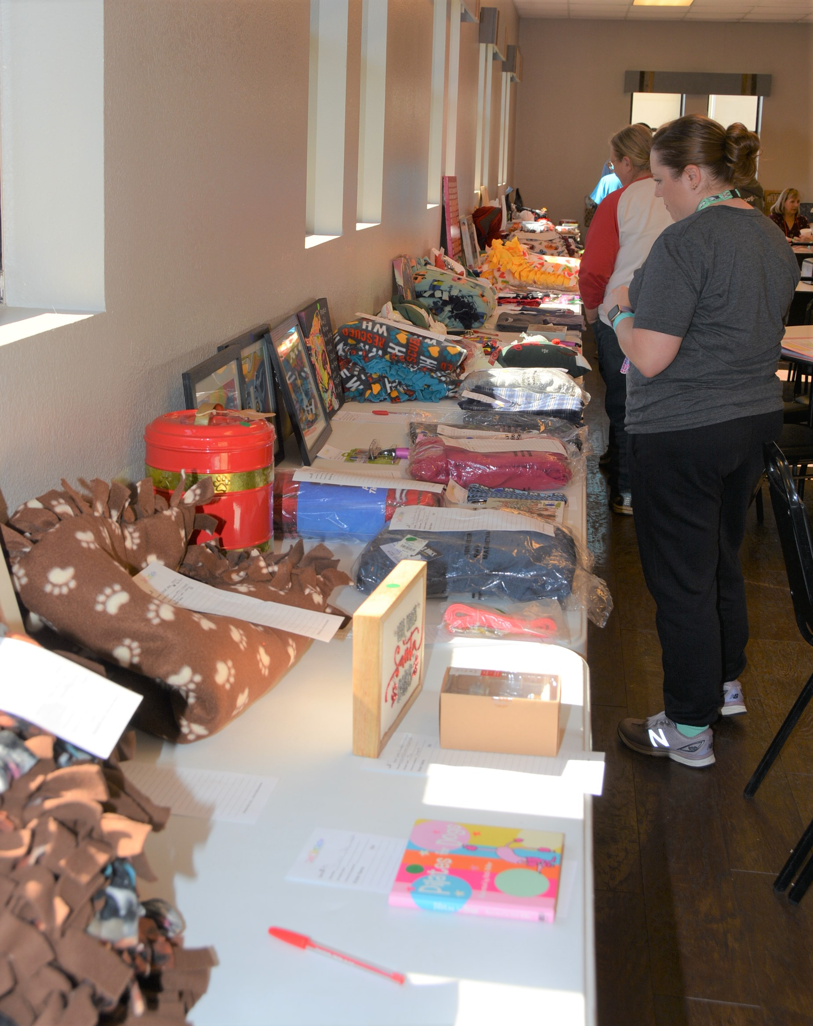
to bring to camp. Don’t forget that we’re having a Not-So Silent
Auction again. This is where we ask everyone to bring a doggie
(or any) item for the campers to bid on to raise money for Dog
Scouts of America. Its great fun, plus we raise lots of money for
the programs of DSA. We call it our “not so silent” auction
because bidding starts on paper, then a very few selected items
are also live auctioned at meal times. If there is an item you like,
please put a bid on the paper slip that corresponds to that item
and try to take care of bidding wars there. By doing most of the
bidding on paper, it saves time during the live auction and we
can see who is interested in the item. We try to be sure interested
persons are in the room, but can’t make any guarantees, so you’ll
want to stick around. Please also make sure you take a good look
at the items before the live bid starts. Having to wait for people to
inspect items that are currently being bid on takes time that we
don’t have (especially if there are LOTS of items to auction). No
item is too big or too small. Most items will be grouped in “lots”
due to the amount of items up for auction. Many of the items
will be pulled for “auto draws” meaning when we pull the auction
sheet, whoever has the last bid gets the item and it doesn’t go
to live auction. Items purchased during the auction will be noted
on your camp tab by the time you check out of camp and pay
your tab. We always have a lot of incredible auction items and
it’s a great place to do your shopping for Christmas, birthdays,
etc. for your dog-loving family and friends (and yourself, too!).
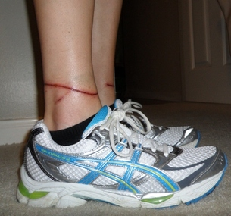

Leashes: Any dog/owner using a retractable leash is automatically on “probation” as far as the leash goes and we will ask you to use another leash if we see it being used inappropriately. We highly recommend non-retractable leashes (just ask our troop member who has a 6-inch scar on her leg from a retractable leash cord burn!)

Pages to print and bring
- Map – to help you find your way around camp until you get familiar
- Schedule –emailed to you- plan your strategy for which activities you’d like to attend
- Waiver/ Release Form –It is available ahead of time for you to read-- you’ll be required to have one be signed and witnessed during check-in at camp. It will save time at check-in if you have already read this form.
- Dog’s Health Form - have this verified by your vet within 30 days prior to camp, preferably between 14 and 30 days prior to camp, then bring it with you. We also recommend you mail or scan and email a copy ahead of time so we are sure to have it just in case you forget to pack it.
- Badge forms: You are encouraged to look at (and print) the badge forms and requirements (check-off sheets) ahead of time online at www.dogscouts.org. Go to the section called “merit badges”, and view the pages you want to work on for this year’s camp (not all badges are available at every camp). We will have some copies of the badge forms at camp but ask that you bring with you the ones you know you are interested in so there’s not a rush Sunday afternoon to print a couple of dozen different badge forms that we ran out of.

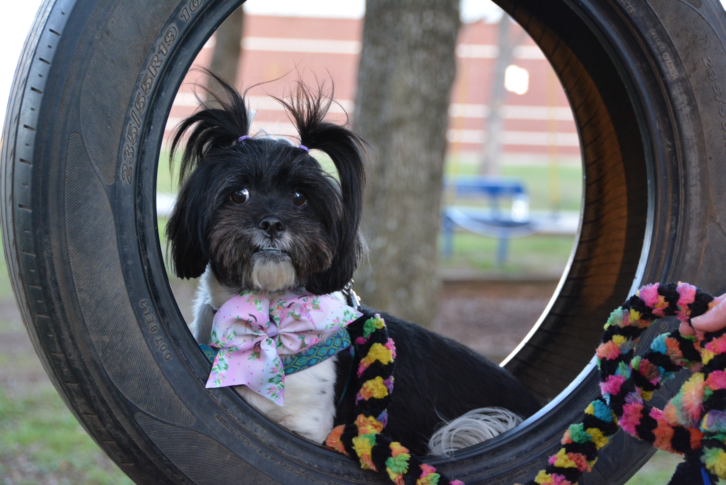

Schedule Changes: While we rarely have any changes, the camp
schedule IS subject to change. We try our best to inform everyone
in advance of these changes, but sometimes the weather or unforeseen
circumstances cause sudden changes. Announcements will be made
at meal-times of any schedule changes. We encourage everyone to
keep a copy of the schedule on you, but we will also have a copy in each
cabin, in the dining hall and in the meeting rooms.

Evaluation forms: Each year we make several changes for the next year’s camp. These changes are usually based on suggestions from the campers or staff. On Sunday, we will ask you all to complete an Evaluation form and we ask that everyone participate. It helps us to know what people liked and what people would like changed. We have had several suggestions implemented based on campers suggestions and they were such great ideas, we were wondering why we didn’t think of them on our own!

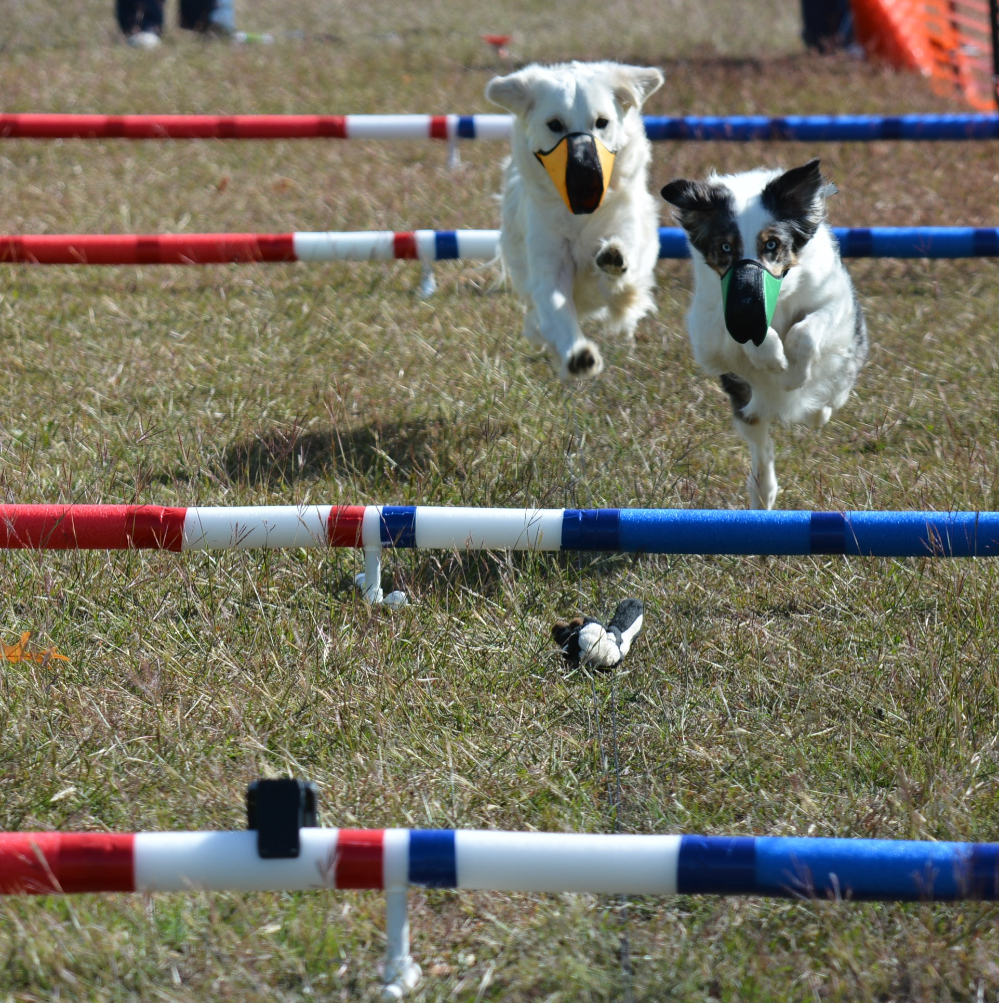

Camper+ Ribbons/ Day Makers – We’re all about positive
reinforcement and this is a way of letting other people know
that they are appreciated. The Camper+ ribbons/ Day Makers
are for camper experience (red), camper dog experience
(white) and fellow camper experience (blue). If you see
another camper having an “aha moment” that you feel is
significant, you can present them with a red ribbon. If you
observe a camper dog having an aha moment, you can present
the owner with a white ribbon. And if someone does
something to make your camp experience better, you can
present them with a blue ribbon. Camper+ ribbons can be
presented to both campers & staff members. Camper+
ribbons will be located on the front tables in the Dogwood Room.

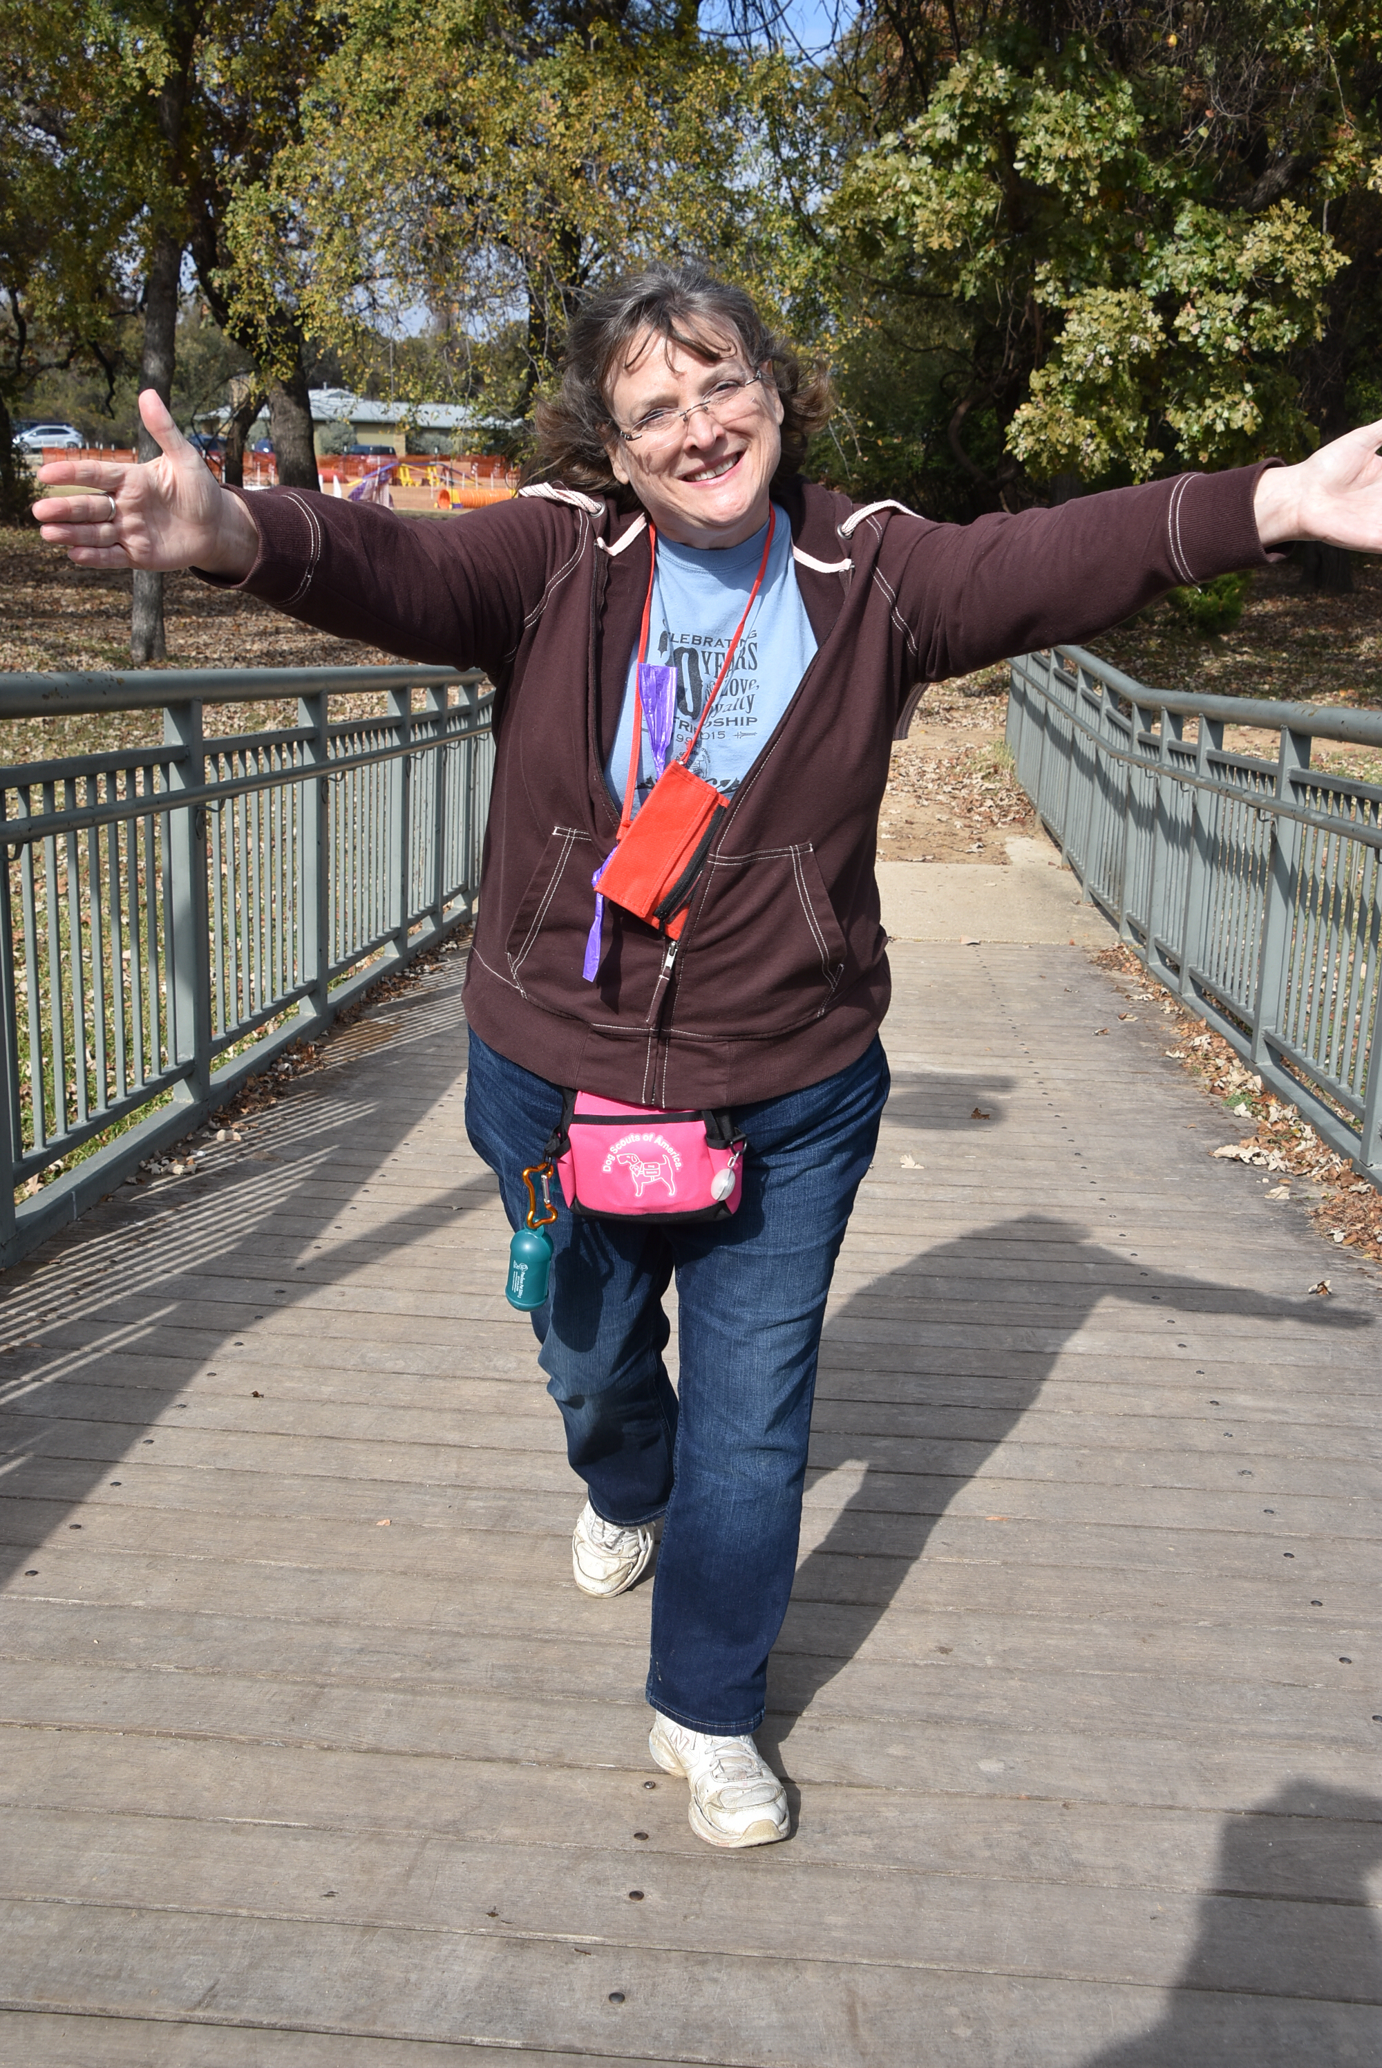
Care Bear –We realize sometimes there may be issues
going on that we are not aware of but no one wants to
step forward and bring to someone’s attention either
because it’s a delicate situation or they don’t want to be
considered complainers or whatever. We don’t always
know which campers are struggling and if someone is
having issues, we want to try to help them have a great
camp experience and not find out after camp is over
that they were struggling and wish we could have
helped. And, it’s just as bad to offer help that is not
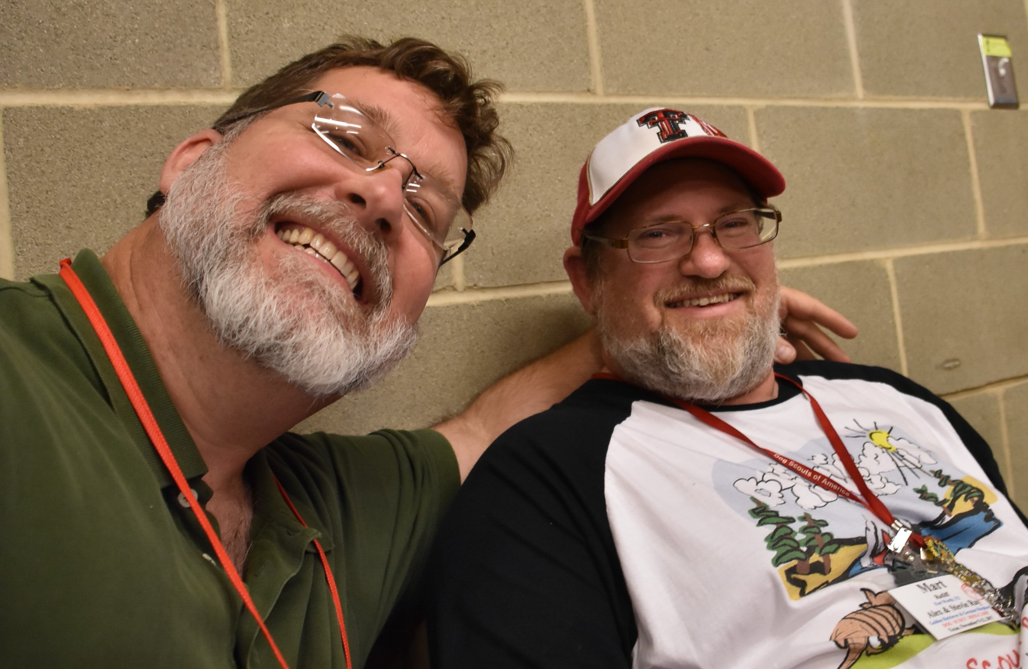
needed (some people get offended), as it is to have
not helped someone who did need some extra “hand
holding.” Since we’re not clairvoyant, and the people
who don’t want help look just exactly like the ones
who desperately need it, we’ve created a “special
Care Bear bag”. If you feel you just “aren’t getting”
the clicker training, for example, or somehow feel
that you are not getting the attention you need from
your instructor, or there is a particular thing that is
puzzling you, or you have a concern with your
roommate, or you think that everyone is too busy,
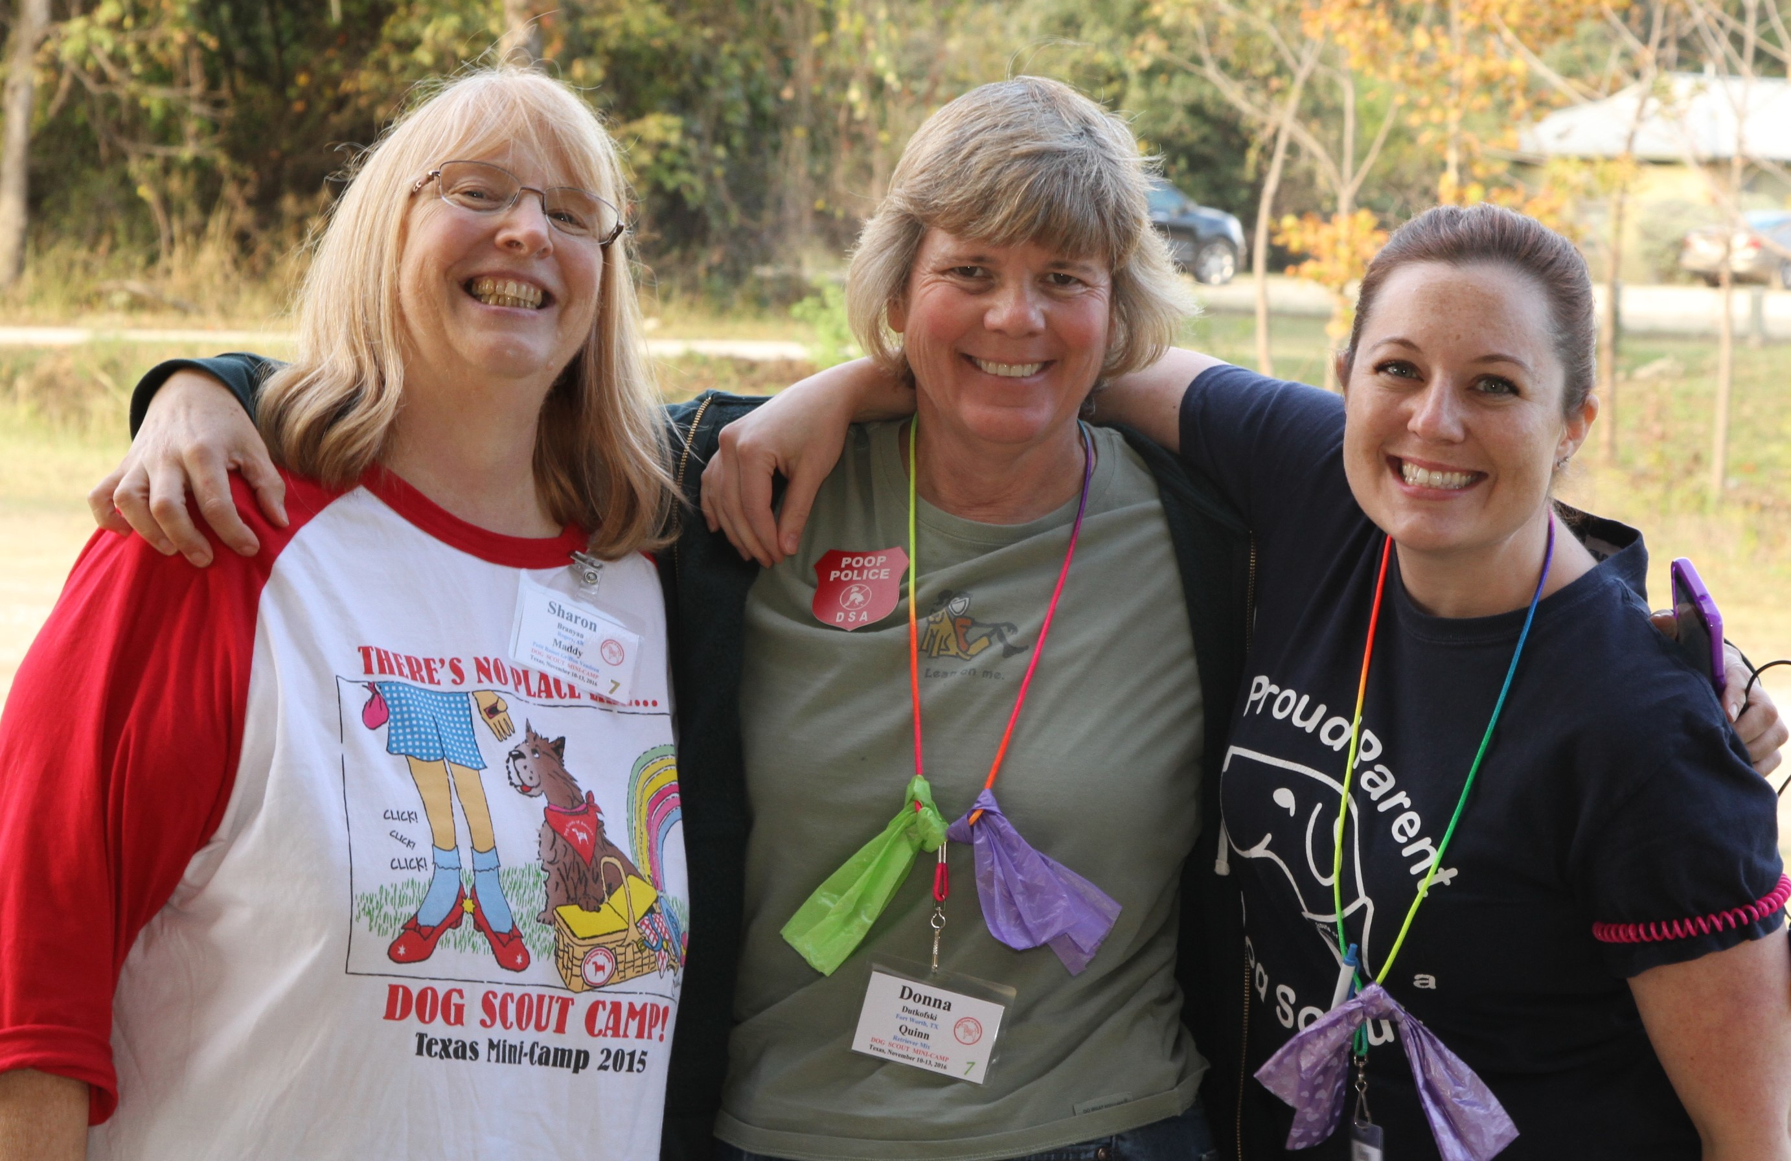
and you don’t want to interrupt them to ask for
additional help, or ANYTHING else, just “tell it to
the bear”. At the end of your rope? Need an extra
hand? Have a question or concern? There’s no
need to wait, just put your concern on paper and
slip it into the Care Bear bag. We want to help.
We do not mean to overlook you, but you may not LOOK like you have
an issue. Because we are not mind readers, we have left it up to you to
seek the help you need. We’re there for you…just ASK. We will read
the concerns in the Care Bear bag several times a day, and address
them ASAP. The Care Bear bag will be on the front table in the
Dogwood

Prizes: We like giving out prizes at Dog Scout Camp and are always looking for opportunities to award prizes! Thank you for doing your pre-camp reading! If you are one of the first five people to email Cindy with the times of quiet time (PM to AM), you will win a prize to be picked up at check-in.
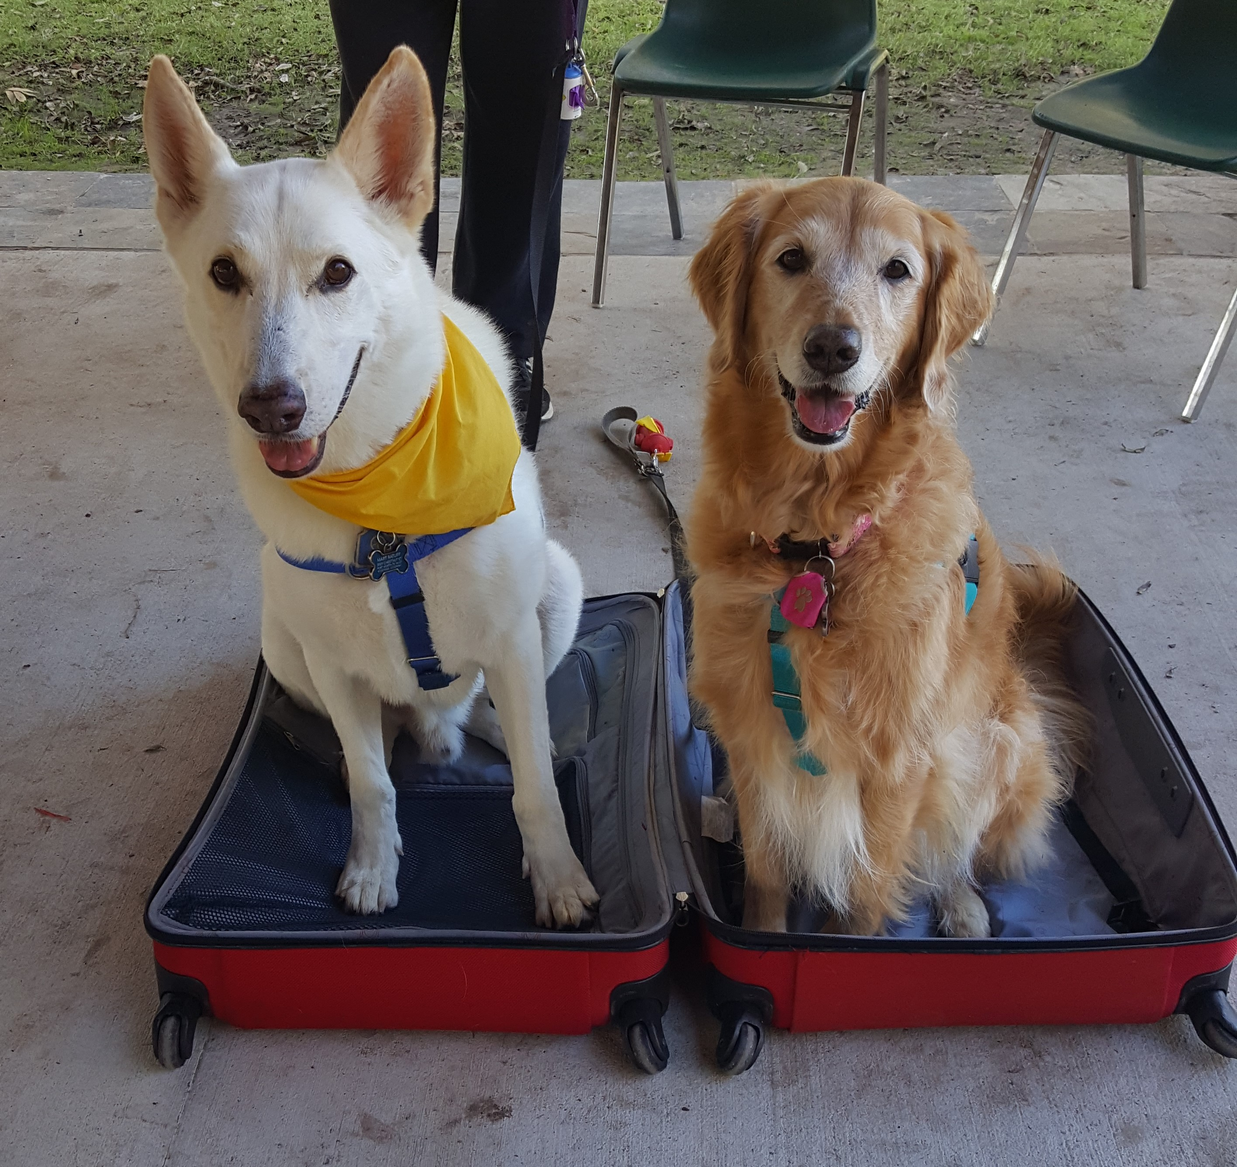

Countdown: Ok. Get psyched up. We are! We are looking forward to camp, and hope you and your dog are, too. If you have any last-minute questions about something not covered in any of these materials, e-mail us and we’ll try to help.

We look forward to seeing you all at camp!
You’ll have a great time and your dog will thank you for it!!

Mart & Cindy

